**Single Inheritance:**

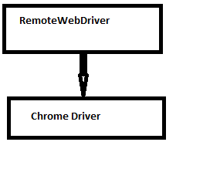

**Multiple Inheritance:**

**Multilevel Inheritance:**

**Hierarchal Inheritance**

**Hybrid Inheritance:**

